Basics of Node JS and NPM

What is the use of packet.JSON file?

So the package.json file serves as the documentation on what all

other packages that your project is dependent upon.

So, for example, when you set up the lite server of your project,

that will be recorded in the package.json file.

And so that, subsequently, you can also make use of that package in the future.

Also, it allows you to specify which specific version of a package

that your project is dependent on.

So even if the package that you depend on changes in the future,

you may insist that you want the user to install only a specific

version of the package for use within your node application.

And also, it makes your builds reproducible,

which means that when you share your code with others,

then they can also do installation of all the node modules

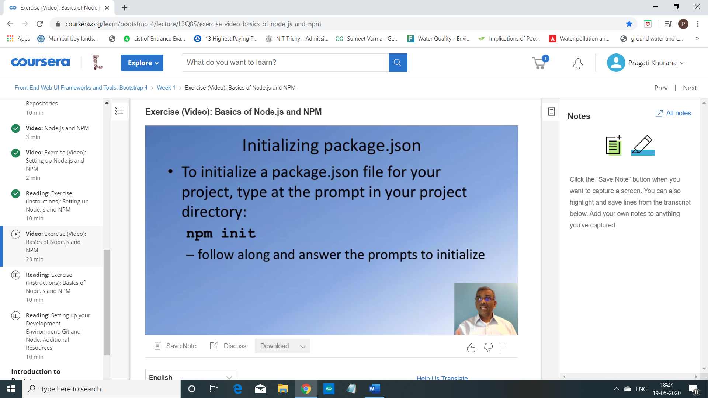

How to create JSON file?

1 : in command prompt go to git-test folder

2 : write npm init

3 : answer following question

Such as … entry point : index.html (if node package then index.js)

4 : JSON file is created in git-test folder

How to install a node module using NPM?

As the next step, we will learn how we can install a node module

using NPM, the Node Package Manager.

So, we're going to install this node module called as light server.

The light server will serve up the contents of this git-test folder in

a server that it starts up so that you can view the contents in a browser.

Given that we have an index.html file,

if we serve up this folder, then it'll be a website.

And you can view the index.html in a browser.

So, let's set up the light server and then we will see how we can make

use of the light server to serve up the contents of this folder.

This is very, very useful because if you're working on a web development

project, you want to see where live version of your web development project.

So that, as you make changes to your project,

you can see the changes immediately reflected in the browser.

So this is a very good node package that is very useful for this purpose.

So let's set up this light server.

To do that, add the prompt.

Type in NPM install.

So notice, if you want NPM to install a node package,

this is how you're going to invoke it and then you'd say lite-server.

And then, we also want to save the fact that our project is using the lite server.

So we will save this information in the package.json file.

So to do that, you're going to type in -- save-dev.

Now the save-dev option specifies that this lite server is used for

development dependency for our project.

If you are installing a node module on which your project is directly dependent

on, then you would install it by simply saying --save option.

Npm install lite-server --save-dev

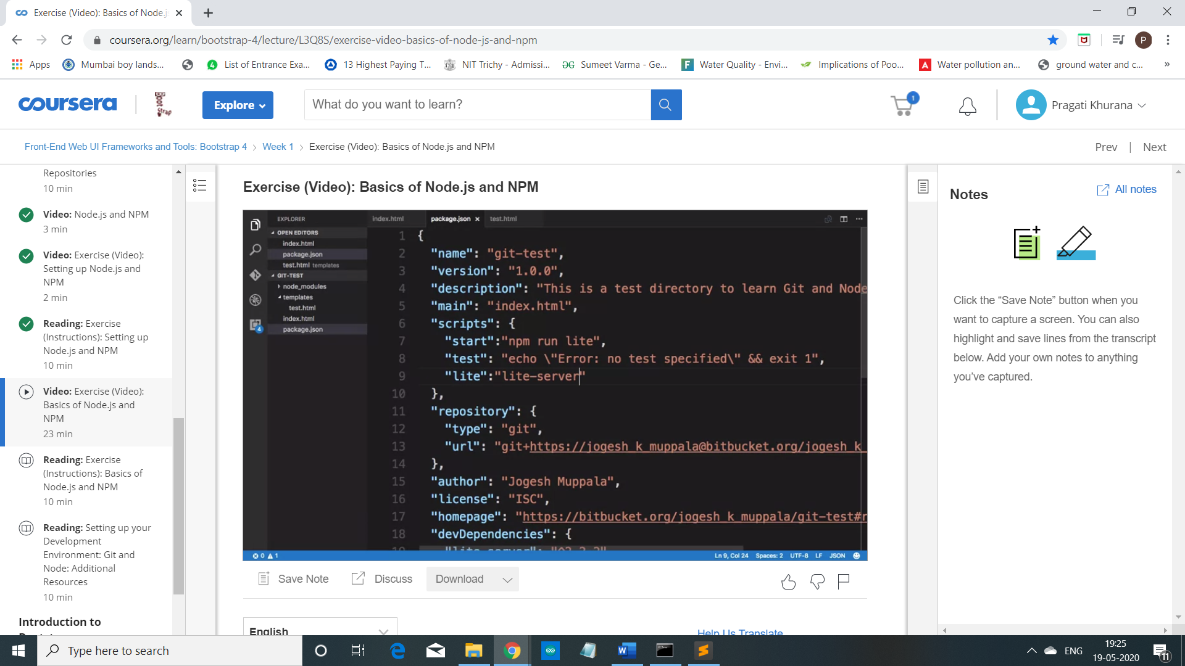

So right here, in this option called scripts,

let's add in one more here.

So we will say "start".

So start is a command that NPM supports which enables

you to specify a bunch of things that will be started.

So later on we will see how we make use of this.

So here I'm going to say "npm run lite".

And after that test, I'm going to add

in one more entry called "lite",

which I will configure as "lite-server", okay?

With these changes, let's save the package.json file.

And then, now our project is configured, so that now if you start the lite- server,

the contents of your folder will be now served up in your favorite browser.

Npm start

It will open index.html in local browser

Changes in index.html

So what I'm going to do now is to show you how you can exclude some

folders from your project folder,

and then make sure that they are not synchronized to your online repository.

Now as I said, the node_modules folder can always be recreated

by typing npm install at the prompt.

So that's why when you upload

the contents of your folder to an online Git repository,

or when you do a commit of the folder to your Git repository,

you don't want the node_modules folder or all the subfolders under it to be

included in the commit.

So how do we exclude some folders or

some files from our folder from being checked in into our Git repository?

So to do that, we will set up a file named .gitignore.

So that's the name of the file, .gitignore.

So to create this .gitignore file, we will go to our editor.

Start transcript at 19 minutes 18 seconds19:18

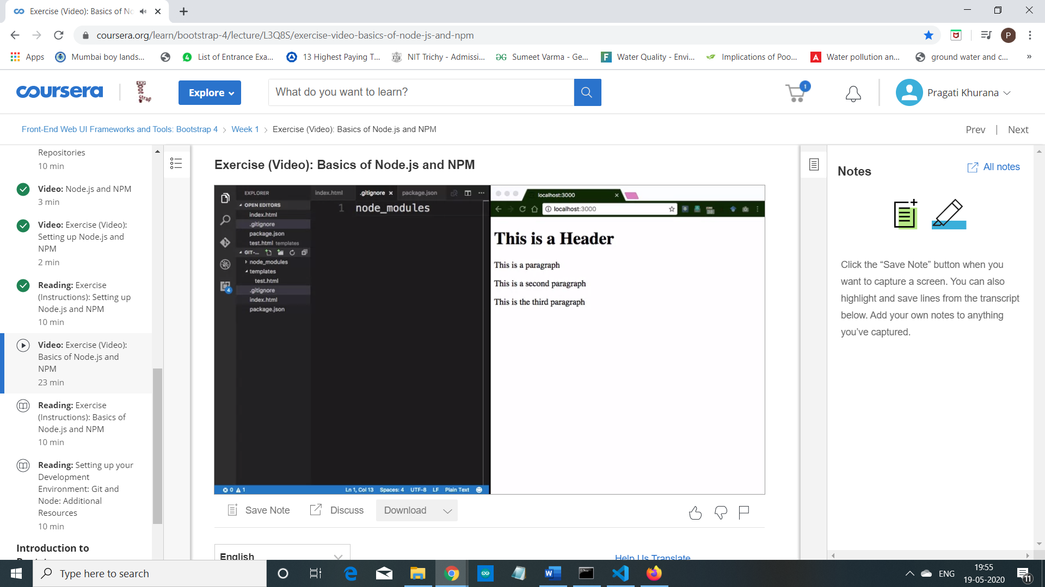

Git status

Git add .

Add commit -m “fourth commit”

Git push -u origin master

We have learned how to install an npm module.

And we have learned how to use the lite-server npm module to serve up

the contents of our project folder so that it can be viewed in a browser.

And then we also saw how we can setup the .gitignore so that some

folders can be excluded from being checked into our Git repository.